

Course: Digital Literacy
Submitted by: Raina Gupta
Registration Number: 25BCE10822

TASK-3 — PLATFORMS

Objective
Learn how to:
- Use online learning platforms
- Participate safely online
- Build digital skills through activity proof

GOOGLE FORMS
Google https://docs.google.com/forms/d/1AlvSiZbceGDl0OEvg0Hu9B35PauCxs9wH1ntVsiMGMM/edit
RESPONSE SHEET

Source: Google Docs https://docs.google.com/spreadsheets/u/0/d/17RM-1u7UBxQ21dCVQH8ntSFpktugW3Kf5SZi7Nl3L2U/htmlview

HACKERRANK

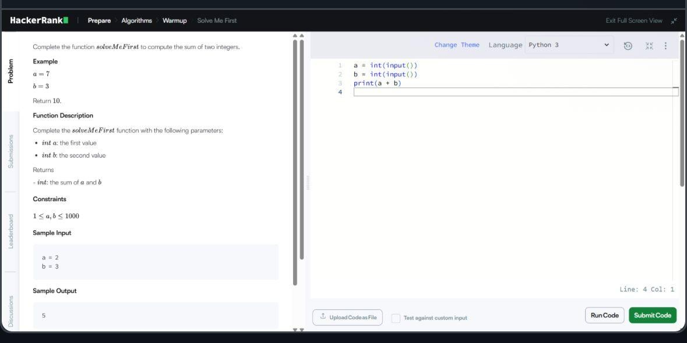

• Creating a Google Form helped me understand how online surveys are designed and used for data collection. I learned how to create different types of questions such as multiple choice, checkboxes, and descriptive responses.

I also learned how to:
- Customize themes and layout
- Share the form using a link
- View responses automatically collected in charts

This activity showed me how digital tools help in research, feedback collection and decision making.

- Creating a Hackerrank account introduced me to online coding practice platforms. I solved beginner programming problems which improved my logical thinking and problemsolving skills.

I learned how to:
- Practice coding online
- Submit solutions
- Track progress and scores
- Build a coding profile

